3GPP TSG-RAN WG1 Meeting #125 R1-2604279
Dalian, China, May 18-22, 2026

Agenda Item: 10.8.3
Source: Huawei, HiSilicon
Title: Waveform and signal for 6GR ISAC
Document for: Discussion and Decision

Introduction
The RAN study on 6G scenarios and requirement documented the sensing related use cases and requirements in the TR [1] as follows:

5.1.17 Sensing-related requirements
Sensing-related capabilities are measured in terms of the following technical performance requirements:
• Detection Probability and False Alarm Probability: Detection probability is the probability of correctly detecting the presence of the sensing target when it is present, and false alarm probability is the associated probability that a sensing target is detected when no corresponding true sensing target is present.
• Horizontal/Vertical Localization Accuracy: It is defined as the absolute difference between the estimated horizontal/vertical location and the actual horizontal/vertical location of the sensing target. The value of localization accuracy shall be obtained assuming 90% confidence level, which is the 90th percentile point of the CDF of the location estimation error. Both the horizontal and vertical localization accuracy are estimated based on Cartesian coordinates.
• Velocity Accuracy: It is defined as the absolute difference between the estimated velocity and the actual velocity of the sensing target. The value of velocity accuracy shall be obtained assuming 90% confidence level, which is the 90th percentile point of the CDF of the velocity estimation error.
In the above technical performance requirements, the sensing target is a passive object, which is not connected to the radio network for communication.
The minimum requirements for Sensing-related requirements are summarized in Table 5.1.17-1.
Table 5.1.17-1: Sensing-related requirements
 | Indoor Factory | Urban Macro
Detection Probability | 95% | 95%
False Alarm Probability | 5% | 5%
Horizontal Localization Accuracy | 2 m | 5 m
Vertical Localization Accuracy | N/A | 8 m (Note 1)
Velocity Accuracy | 2 m/s | 4 m/s

5.4.4 Sensing
Editor note: More sensing use cases can be included depending on further discussion.
The 6GR and 6G RAN architecture shall at least support use cases of
- detection and/or tracking of passive objects, at least including UAVs, human, vehicles and AGVs
- communication assistance.

For the RAN1 study [2] on 6G Radio, the sensing related objectives agreed for the study are as follows:
(9) Sensing – Studies to be based on use cases and associated requirements, as defined in [TR38.914]
- PHY functions and procedures for sensing technology (e.g., waveform. reference signals, measurement feedback, etc…) [RAN1, RAN4]
- Evaluate sensing performance and if necessary, extend channel modelling, for the selected use cases [RAN1]
- Aspects of integration with communication services [RAN1]
- higher layer procedures and protocol aspects [RAN2]
- RAN4 aspects of sensing including RF, coexistence, and testability in coordination with other WGs [RAN4]
Note: RAN1 identify detailed requirements, if triggered by TSG RAN

The general considerations for 6GR sensing study are discussed in the companion paper [3]. This contribution discusses the waveform and signal aspects for sensing in particular.

Metrics and design principles
The last meeting discussed how to evaluate the waveform and/or sequence for sensing as captured as follows.
Agreement:
Companies are encouraged to provide views on necessity/pros/cons/metrics of LLS and/or SLS and pros/cons/metrics of theoretical waveform characteristics analysis, for evaluation of ISAC waveform and/or integration with communication, to RAN1#125 meeting.

In our view, at least the thermotical waveform characteristics analysis is the most straightforward as the first step evaluation.
- Sensing performance metrics
As discussed in [3], the wireless resources of interest for sensing includes physical channels and signals. This section discusses the design principle for signals and waveform for physical channels from sensing perspective.
The principle for sensing waveform and signal design is different from that for communication. Particularly, sensing waveform should provide good detection rate, low false alarm rate, and fine estimation accuracy under certain coverage. These KPIs can be represented by the well-known metric of ambiguity function, Peak-to-sidelobe ratio (PSLR), and Integrated Side Lobe Ratio (ISLR) provided below:
- Ambiguity function [4]: Ambiguity function represents the distortion of a returned pulse from a target under typical matched filter receiver.
$AF\left(τ,v\right)=\int_{Φ}{s\left(t\right)s^{*}\left(t-τ\right)e^{i2πvt}}dt$,
where $Φ$ is the integration region of ambiguity function, $τ$ is delay and $v$ is Doppler taking continuous value.
- PSLR [4][5]: The definition of PSLR generates from the ambiguity function. The PSLR is viewed as an important KPI to evaluate the power of side lobe. The PSLR is defined as
$PSLR=20log⁡(\frac{P_{1}}{P_{0}})$,
where $P_{0}$denotes the largest value of the main lobe of ambiguity function, and $P_{1}$ is the largest value of the side-lobe of ambiguity function.
- ISLR [4][5]: Similar to PSLR, ISLR is another method to evaluate the side-lobe power of ambiguity function. The definition of ISLR is as follows
$ISLR=10log⁡(\frac{I_{side-lobe}}{I_{main-lobe}})$,
where $I_{main-lobe}$ denotes the power of the main-lobe, and $I_{side-lobe}$ denotes the total power of side-lobe.
These evaluation metrics demonstrate the required waveform properties for sensing in a clear way as shown in Figure 1. Specifically, the main lobe of the AF represents the sensing target detection accuracy. The narrower main lobe, the better accuracy of the target detection. The side lobe performance of the AF (PSLR, ISLR) represents the capability to detect the weak target. The lower Side lobe, the better detection rate and accuracy for weak target.
Object 1 Echo Pulse
Object 2 Echo Pulse
(1) Narrower main lobe, better accuracy for target detection
(2) Lower Side lobe, better detection rate and accuracy for weak target
The echo pulse is determined from the AF
Delay/Doppler
Figure 1: Waveform properties for sensing
In addition, similar to the discussion in waveform AI, Tx power gain (a more accurate representation than PAPR gain) should also be considered as an important metric. The higher Tx power gain can be equivalently converted into a longer maximum-detection range, since the higher transmitted power generally improves the received echo strength. With limited time-frequency-spatial domain resource, higher transmit power contributes to higher sensing reliability by enhancing detection capability.
Proposal 1: Ambiguity function is used to characterize waveform for ISAC/sensing,
$AF\left(τ,v\right)=\int_{Φ}{s\left(t\right)s^{*}\left(t-τ\right)e^{i2πvt}}dt$,
where $Φ$ is the integration region of ambiguity function, $τ$ is delay and $v$ is Doppler with continuous value.

Proposal 2: PSLR, ISLR, Tx power gain are used as the performance metrics for ISAC/sensing waveform and signal study.
- PSLR is defined as the ratio of the highest sidelobe peak to the main-lobe peak in a correlation response:
$PSLR=20log⁡(\frac{P_{1}}{P_{0}})$,
where $P_{0}$denotes the largest value of the main lobe of ambiguity function, and $P_{1}$ is the largest value of the side-lobe of ambiguity function.

- ISLR is defined as the ratio of the total sidelobe energy to the main-lobe energy in a correlation response:
$ISLR=10log⁡(\frac{I_{side-lobe}}{I_{main-lobe}})$,
where $I_{main-lobe}$ denotes the power of the main-lobe, and $I_{side-lobe}$ denotes the total power of side-lobe.

- Tx power gain is defined as the PA power back off gain, which is the gain of the maximum transmit power compared with the baseline waveform in compliant with a set of requirements, such as IBE, ACLR and EVM.

- Communication Performance metrics
The communication performance evaluation could follow the traditional communication evaluation methodology and metrics, such as BLER, spectral efficiency and Tx power gain. Note that The Tx power gain evaluation should be based on PA model(s) and RF requirements, where PA model can follow RAN4 agreements.

In addition, when some of simulations are needed, which channel model is used for the simulation has been controversial and time consuming for the discussions. In our view, as one further step to move forward, the proponents can justify the relative gain of the enhancement compared to the benchmark using the channel model decided by the proponents first, so that RAN1 does not need to first spend much time on discussing the channel model for this purpose then.
Proposal 3: As one further step to move forward, the proponents can justify the relative gain of the enhancement compared to the benchmark using the channel model decided by the proponents for the waveform/sequence study for ISAC.

ISAC resource definition
As discussed in [3], the physical channels/signals for sensing could be categorized into two types. Type1 resource is sensing performance oriented, e.g., the resources for coherent processing to measure Doppler, which would result in larger time domain resources overhead that is not necessarily needed and expected to be avoided in general for communication. Type2 resource is shared with communication and the design is expected to provide good performance for both sensing and communication. Both types should be studied for 6GR ISAC.
- Type1 resource for sensing-oriented
Existing communication signals are primarily optimized for communication purposes rather than sensing performance. For example, SRS is based on ZC sequences, which provide relatively good PAPR characteristics but may not achieve extremely low PAPR. This is a reasonable trade-off for communication, where frequency-domain flatness is important for channel estimation and MIMO precoding. However, from sensing perspective, transmit power may be more critical, as it directly affects the received sensing SNR and hence the achievable sensing range and detection performance. At the same time, the frequency-domain flatness may not be that important as sensing signals can be carefully designed to provide desirable ambiguity function properties, e.g., good delay/Doppler resolution and low sidelobes.
Rather, on Type1 resources, the reference signal can be optimized for sensing performance.
Proposal 4: 6GR ISAC should study reference signal design for Type1 resource that is sensing performance oriented.

- Type2 resource for sensing and comm.
In some scenarios, the communication channel measurements derived from existing 5G NR reference signals, e.g., CSI-RS and SRS, can also be applicable to the sensing channel measurements, e.g., in bi-static ISAC modes such as “aNB-UE” and “UE-aNB” sensing. In such cases, sensing information, such as the delay and angle of a target can be extracted through further processing based on the CSI-RS or SRS measurement.
Compared with RS configured on Type1 resources or Type2 resources, communication data resources are typically more frequent and denser in both time and frequency domain, particularly in medium or high-load scenarios. Therefore, in some scenarios, reusing communication data for sensing may achieve better sensing performance for both mono-static and bi-static sensing due to the increased signal availability. Based on the above, it is beneficial to study on waveform design for Type2 resources, including the feasibility and potential benefits of using communication data as sensing signals.
Proposal 5: 6GR ISAC should study reference signal design and waveform for physical channels for Type2 resource that is shared with communication.

Sensing signals for Type1 resource
Agreement:
CP-OFDM waveform as defined for 6GR is the starting point for 6G ISAC waveform study.
- Study on enhancements on CP-OFDM or other waveforms is not precluded.
In 5GR, only mono-static sensing is considered and it relies on gNB’s implementation. Therefore, the protocol does not restrict the specific waveform used for sensing signal transmission. However, if the sensing RS is not OFDM-based, e.g., FMCW or LFM, it may cause strong interference to transmissions in neighboring cells. As a result, neighboring cells may need to instruct UEs to avoid the corresponding resources in order to mitigate such interference, which would reduce overall system throughput. In 6GR, in addition to aNB’s mono-static sensing, sensing scenarios involving UE transmission and reception are also under discussion. Therefore, such coexistence issues should be avoided in the sensing RS design. In our view, the sensing signal for Type1 resources in 6GR should follow a unified waveform structure that takes compatibility with communication waveforms into account. Hence, sensing signals for type1 resource should consider OFDM-based waveform structure.
Proposal 6: Sensing signals for type1 resource should consider OFDM-based waveform structure.
Type1 resource is sensing performance-oriented and is not needed and expected to be avoided in general for communication.
Existing 5G NR reference signals, specifically, Zadoff-Chu (ZC) based SRS and Gold-sequence based CSI-RS exhibit near-ideal periodic autocorrelation at integer lags. This provides the foundational time-domain resolution required for basic sensing. Additionally, these signals also offer implicit angular and spatial awareness, as evidenced by PMI feedback mechanisms that reflect inherent angular estimation capabilities. Furthermore, their sequence generation frameworks support an extensive pool of orthogonal or quasi-orthogonal sequences, ensuring robust scalability for multi-user and multi-cell deployments.
Therefore, it is natural to adopt existing 5G NR reference signals as the baseline for Type1 RS due to their inherent sensing capabilities and sufficient sequence capacity.
Proposal 7: NR reference signals (RS), e.g., CSI-RS, and SRS, can be the starting point for sensing RS design and evaluation for Type1 resource that is sensing performance oriented.

Waveform and RS for Type2 resource
Type2 resource is shared for sensing and communication. Reference signals and waveform for the physical channels will be studied for both sensing performance and communication performance.

5.1 Waveform for physical channels

5.1.1 ISAC waveform discussion
Agreement:
CP-OFDM waveform as defined for 6GR is the starting point for 6G ISAC waveform study.
- Study on enhancements on CP-OFDM or other waveforms is not precluded.

In the last meeting, it was agreed that the CP-OFDM waveform as defined for 6GR should be the starting point for the 6G ISAC waveform study, while enhancements to CP-OFDM or other waveforms are not precluded. Based on this agreement, there exists following two categories of potential waveforms:
- Cat.1: Waveforms requiring no fundamental changes to UE implementation
- Cat.2: Waveforms requiring fundamental changes to UE implementation
For Cat.1 waveforms, which do not require changes to the UE hardware architecture, receiver processing, or signal storage/processing structure are involved, examples include CP-OFDM and DFT-s-OFDM.
For Cat.2 waveforms, which need to change to the UE hardware architecture, receiver processing, or signal storage/processing structure are involved, examples include LFM, pulse-based waveforms, OTFS, and AFDM.
For ISAC waveform design, one key objective is to maximize the reuse of existing communication signals, so as to reduce the system overhead. From this perspective, Cat.1 waveforms can serve as reasonable candidate waveforms. These two waveforms are already supported in 5G NR and are also adopted as 6G waveforms. In addition, waveform evolution for 6G (e.g., low PAPR enhancement on discussion in RAN1 AI 10.2.1) is generally expected to maintain compatibility with legacy CP-OFDM and DFT-s-OFDM waveforms supported by existing protocols.
By contrast, if Cat.2 waveforms is introduced for ISAC, legacy communication devices can’t be able to support it directly. For example, LFM-based waveforms may require additional UE hardware components, such as a chirp mixer circuit, which would introduce extra hardware cost. For pulse-based waveforms, the UE may require dedicated wideband pulse detection circuitry, high-speed time-domain sampling, and high-resolution timing detection modules to capture short-duration pulses and estimate their time of arrival. AFDM, is a DAFT-based, rather than DFT-based waveform using multi-chirp basis. For communication, changing the waveform basis would require substantial modifications to the existing design framework, e.g., DMRS design, channel estimation, and equalization, while no clear benefit has been identified. On the other hand, OTFS can be viewed as an inter-symbol extension of DFT-s-OFDM, additional two-dimensional signal processing receiver on delay-Doppler domain is required for communication perspective. This would introduce a significant processing delay and complexity to the receiver. From the sensing perspective, no clear sensing-performance advantage over DFT-s-OFDM has been observed.
As discussed above, no obvious benefit can be observed or extra cost is needed for introducing Cat.2 waveforms for ISAC purpose. Therefore, focusing on Cat.1 waveform, e.g., CP-OFDM- and DFT-s-OFDM-based waveforms and their related enhancements is a reasonable approach.
Proposal 8: The study of 6G ISAC waveform should focus on CP-OFDM and DFT-s-OFDM-based waveforms and their related enhancements.

5.1.2 Potential enhancement on waveform
Motivated by using data for sensing so as to reduce the resource overhead, it is beneficial to further study new designs based on current CP-OFDM or DFT-s-OFDM waveform that can potentially achieve a better trade-off between sensing and communication performance.
When CP-OFDM waveforms employ modulation orders higher than QPSK, e.g., 16QAM or 64QAM, the transmitted signal may exhibit increased frequency-domain non-uniformity, which can degrade AF metrics and eventually lead to sensing performance loss. Therefore, while retaining the communication capacity benefit of higher-order modulation, signal design with enhanced frequency-domain flatness for modulation orders higher than QPSK can be considered, so as to achieve a more favorable trade-off between communication throughput and sensing performance.
One possible candidate could be Pruning QAM. As shown in Figure 2 below, 8 constellation points are removed from the 16QAM constellation diagram, leaving the remaining 8 constellation points to form the 8 pruning QAM constellation. From the pruned constellation, the distances from the 8 constellation points to the origin are the same. It means that the constant envelope can be retained in CP-OFDM, yielding lower ISLR and PSLR compared with the original 16QAM.
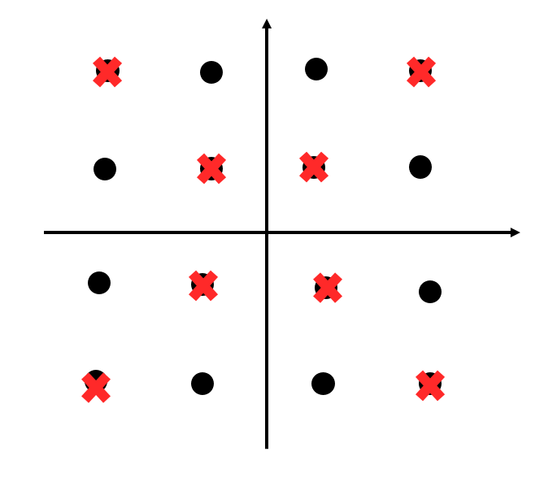
- constellation points for pruning QAM (b) AF metrics comparison with other modulation
Figure 2: One example of AF metrics enhancement
DFT-s-OFDM waveform is capable of supporting higher transmit power, which contributes to enhancing the maximum detectable distance of sensing. Nevertheless, due to the DFT processing in DFT-s-OFDM system, the frequency envelope is inherently non-constant, which will increase the side-lode in the AF of range.
One possible candidate could be frequency-domain floor clipping for DFT-s-OFDM and thus decrease the frequency ripple. By doing so, the relatively constant envelope can be achieved, and thus ensure a low side-lobe. Figure 3 demonstrates the frequency-domain floor clipping in DFT-s-OFDM. The clipping scheme can be illustrated below, where $C$ denotes the threshold.
$$\tilde{X}\left(k\right)=\left\{\begin{matrix}X\left(k\right) if \left|X\left(k\right)\right|≥C \\ Ce^{j∠X(k) } Otherwise\end{matrix}\right.$$

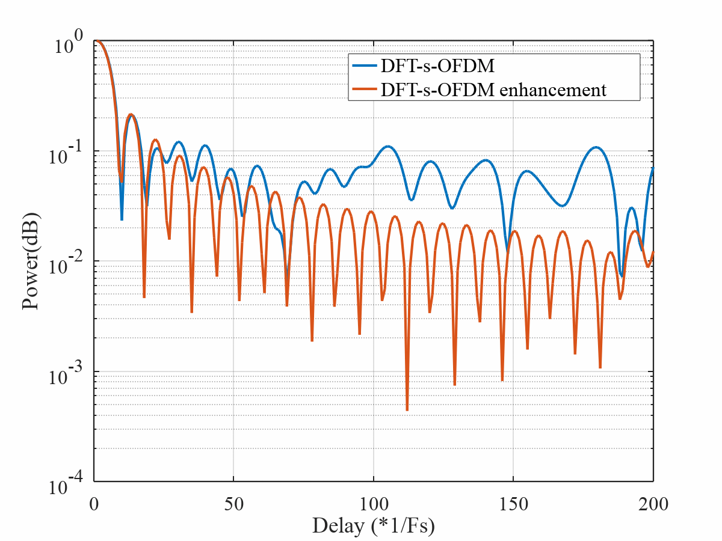
- Frequency-domain floor clipping (b) AF metrics comparison with DFT-s-OFDM

Figure 3: One example of AF metrics enhancement for DFT-s-OFDM

Proposal 9: For performance comparison to the benchmark, the new waveform design that can achieve better trade-off between sensing performance and communication performance could be considered.
Proposal 10: Physical channel waveforms candidates for study on Type2 resources shared with communication include
- Pruned QAM for CP-OFDM based
- Floor clipping for DFT-s-OFDM based

5.2 Reference signals for sensing
The existing NR reference signals serve as the most pragmatic starting point and evaluation benchmark for Type2 reference signals. First, these reference signals have been extensively verified to provide robust channel estimation and synchronization performance in NR. Second, as discussed in previous sections, such sequences already possess inherent sensing and interference-rejection capabilities that can provide basic sensing service requirements, such as delay, speed and angle. Most importantly, any transition toward a specialized ISAC reference signals must prioritize the preservation of communication efficiency. As a joint design could potentially introduce trade-offs in sensing performance and communication performance, adopting existing sequences as a baseline ensures that sensing enhancements do not come at the cost of significant communication performance loss. Therefore, using current NR reference signals as a starting point provides a stable benchmark, and any proposed sensing enhancements should achieve an optimal balance between the two functionalities.
Proposal 11: NR reference signals (RS), such as CSI-RS, and SRS, can be the starting point for the RS design and evaluation for Type2 resource that is shared with communication.

Study on potential enhanced RS for sensing
As discussed in sections 4 and 5, NR reference signals (RS), e.g., CSI-RS, and SRS, can serve as the starting point for sensing RS design and evaluation, both for Type1 resources that are sensing performance oriented and for Type2 resource that are shared with communication.
As discussed above, the motivation for the enhancement is to achieve lower PAPR and improved sensing performance. With that, the impact on communication in terms of performance and/or resource overhead and the potential impact on the implementation complexity should be considered as well for the study.
- Enhancement on low PAPR sequence
Low-PAPR design is important for enabling transmit power boosting, which may directly impact the sensing performance, such as achievable sensing detection range. For UE-aNB bi-static sensing mode, since the device is typically power-limited, a low-PAPR waveform can provide transmit power gain by enabling more efficient use of the UE power amplifier. For downlink sensing, considering that the sensing RS may often occupy the full transmission bandwidth and does not necessarily need to be frequency-division multiplexed with other data, a low-PAPR waveform can also provide transmit power gain.
As discussed above, SRS is based on ZC sequence, and it is a good solution for communication due to its constant envelope in frequency domain and good PAPR performance. However, the PAPR of ZC-sequence-based waveforms depends on the selected root, and different roots can result in different PAPR values. To achieve a more controllable and stable low PAPR performance, DFT-s-OFDM with pi/2-BPSK can be considered as another candidate solution as illustrated in Figure 4. This approach can avoid the issue of high and root-dependent PAPR associated with ZC-sequence-based designs, while maintaining the waveform PAPR at an extremely low level. As a result, it can increase the available transmit power and improve the sensing distance.
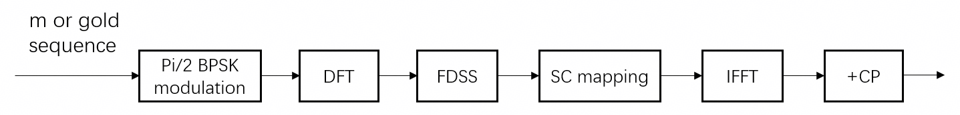
Figure 4: DFT-s-OFDM with pi/2-BPSK for sensing RS
The scheme of Pi/2-BPSK with transparent FDSS is already adopted in 5G uplink low PAPR enhancement for DFT-s-OFDM for data transmission and its corresponding DMRS [6]. For sensing RS, the m or gold sequence defined in 5G, can be firstly generated and further modulated by pi/2 BPSK, as shown in Figure 4. The initial seed can be properly chosen to achieve good correlation performance.
PAPR performance comparison of SRS (e.g., root = 370) and gold sequence-based pi/2 BPSK with or without FDSS filter is given in Figure 5. FDSS (with the roll-off factor of $β$) based ZC sequence can achieve a PAPR of 3dB at CCDF @10⁻². pi/2 BPSK DFT-s-OFDM with FDSS filter can achieve a PAPR@1.6dB. The reduced PAPR can enable a higher UE Tx transmit power gain by approximately 3dB so as to increase 3dB SNR gain for sensing compared with pi/2 BPSK with FDSS filter and SRS.
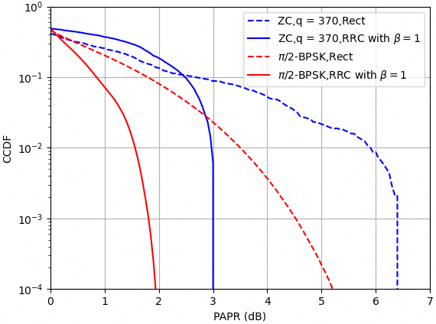
Figure 5: Low PAPR enhancement

In the RAN1 AI 10.2.1 6GR waveform discussion and RAN4 AI 8.3.2 discussion, low PAPR enhancements are still under discussion. Therefore, waveforms with lower PAPR, such as OQAM (e.g., pi/2-BPSK with spectrum extension or truncation), which may provide a better trade-off between PAPR reduction and sensing performance can be further studied. The study of low PAPR enhancement for ISAC can follow the progress of the RAN1 AI 10.2.1 and RAN4 AI 8.3.2, as the low PAPR enhancement will also be used in 6GR uplink communication and the Tx power gain of low PAPR enhancement will be evaluated by RAN4.

- Enhancement on ambiguity function metrics

- Lower PSLR for consecutive symbols
Decreasing the auto-correlation sidelobe is critical for multi-target sensing scenarios, as high sidelobes from strong targets may mask the main-lobes of nearby weak targets, which may happen under bi-static uplink and downlink sensing scenarios. Moreover, energy leakage from strong-target sidelobes into the main-lobe region of weak targets may cause peak displacement, degrading ranging accuracy. Therefore, reducing auto-correlation sidelobes through sequence design improves detection probability and distance estimation precision. Although constant modulus sequences like ZC and Gold offer ideal periodic auto-correlation at integer delay shifts, their performance deteriorates significantly when considering non-integer (fractional) delay grids, with sidelobes that decay following a sinc-like envelope. The resulting high auto-correlation sidelobes lead to a "masking effect" on non-integer grids, where the energy leakage from a strong target can submerge the peaks of weaker adjacent targets.

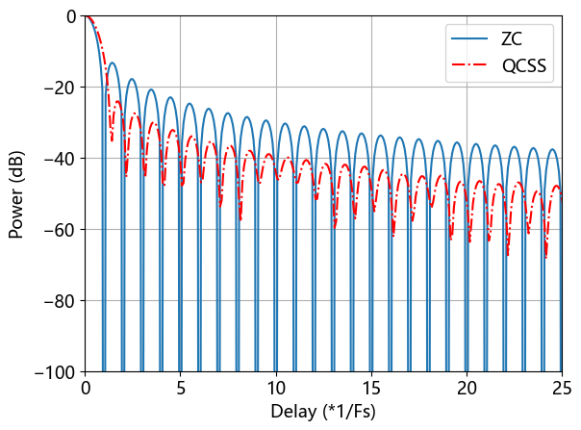
Figure 6: Low sidelobe on non-integer grids
In order to achieve such low sidelobe on non-integer grids, one possible candidate is quasi-complementary sequence set (QCSS). A QCSS typically consists of multiple groups of sequences, where each group contains K individual sequences. These K sequences can be mapped onto K consecutive OFDM symbols as shown in Figure 7.
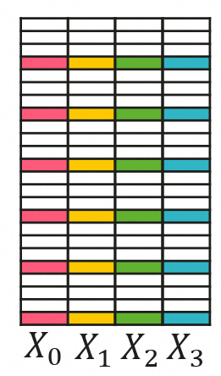
Figure 7: QCSS-based Lower sidelobe enhancement
Joint sensing processing can be performed across multiple OFDM symbols based on the coherent combination of the ambiguity functions on individual symbols, which can effectively reduce the sidelobes compared with single sequence design, as shown in Figure 6. At the same time, since the overall ambiguity function is determined after combining multiple symbols, conversely, the ambiguity-function constraint on each individual OFDM symbol can be relaxed, which provides more design freedom for other function trade-off, such as PAPR reduction. The detailed procedure for generating QCSS signals is provided in the Appendix. Based on this generation method, the resulting performance for a sequence length of 273 over 4 OFDM symbols is evaluated, as illustrated in Figure 8. Regarding ambiguity properties, both the PSLRs of the auto-ambiguity function and the cross-ambiguity function are reduced by approximately 10 dB @ Doppler cut 0, compared with ZC sequences. Besides, the proposed QCSS demonstrates a significantly reduced PAPR, reaching approximately 2dB.
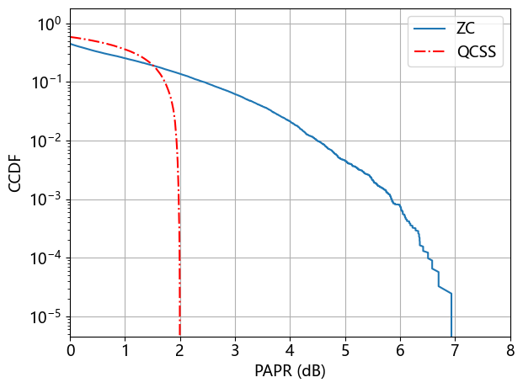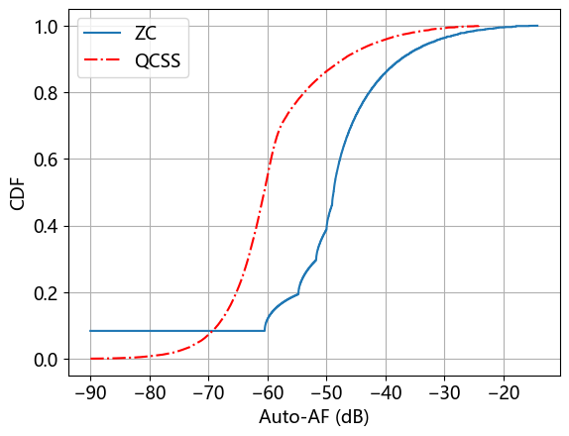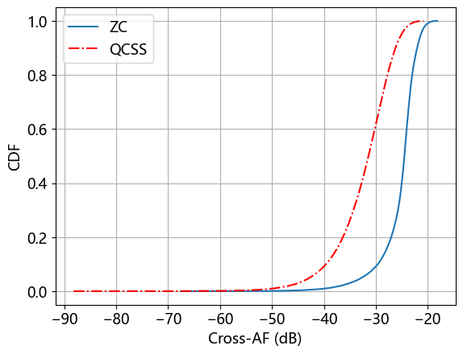
Figure 8: The PAPR, Auto-AF (@ Doppler cut 0), and Cross-AF (@ Doppler cut 0) of QCSS versus ZC sequence.

- Flexible PSLR adapting to sensing scenarios
The AF shall be flexibly changed according to different sensing scenarios based on aNB-UE and UE-aNB bi-static sensing modes. Take the use case of target detection and tracking as an example: in the detection stage, the low sidelobe level is prioritized over the sharp main lobe to ensure the detection rate of weak target; by contrast, in the tracking stage, the sharp main lobe is preferred to estimate the sensing parameter precisely since prior information about the target is already known.
Accordingly, it is necessary to investigate the method for the trade-off between main lobe width and sidelobe level of AF of sensing signals adapted to different sensing scenarios. Frequency Domain Spectrum Shaping (FDSS) with different filters for different scenarios can be considered as a feasible candidate for the trade-off between the main lobe width and sidelobe level of the AF as shown in Figure 9. The FDSS is applied to the sensing signal at the transmitter, and correspondingly, the receiver performs matched filtering processing based on the transmitter’s FDSS configuration to improve the sensing performance at the specific sensing scenario.
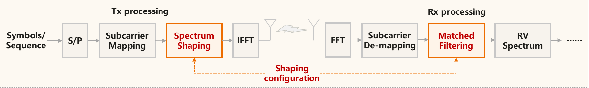
Figure 9: FDSS for sensing
For example, at detection stage, low sidelobe for weak target detection is preferred, so the FDSS2 filter can be considered; at tracking stage, sharp main lobe for better accuracy is preferred, so the FDSS1 filter can be considered. The AF properties for the two FDSS filters are illustrated in Figure 10.
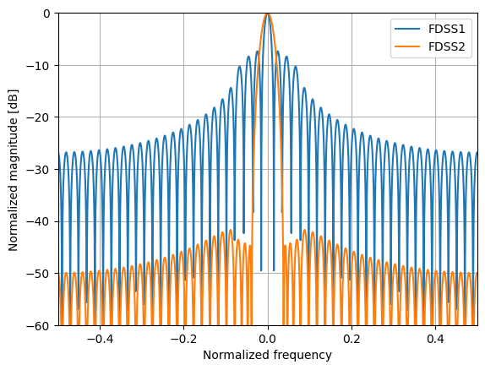
Figure 10: Different FDSS leads to different AF properties.

FDSS for sensing performs an element-wise multiplication between the frequency-domain sequence under OFDM modulation and a window sequence $w\left[k\right]$ at the transmitter. The frequency-domain sequence $a\left[k\right]$ of the sensing RS after FDSS can be expressed as
$a\left[k\right]=a^{'}\left[k\right]w\left[k\right], k=0,1,…,K-1$,
where $a^{'}\left[k\right]$ denotes the original frequency-domain sequence of the sensing RS before FDSS such as Gold sequence and ZC sequence, the k is the element index of sequence, the K is the length of sequence, respectively.
Correspondingly, the receiver performs matched filtering processing to obtain the measurement of the sensing channel. The output of matched filtering processing $h\left[k\right]$can be expressed as
$h\left[k\right]=r\left[k\right]\overline{a[k]},k=0,1,…,K-1$,
where $\overline{a[k]}$ denotes the complex conjugate of $a\left[k\right]$, and $r\left[k\right]$ denotes the received sequence after OFDM demodulation.
Various types of window sequences are available for FDSS for sensing, and one possible candidate is the Chebyshev window or its approximate Taylor window. These window sequences allow flexible parameter adjustment, enabling an adaptive trade-off between the main lobe width and sidelobe level of the ambiguity function across different sensing scenarios. The aforementioned window sequence can be generated by the Chebyshev window or the Taylor window, as follows:
$w\left[k\right]=\sqrt{cheb\left[k\right]},w\left[k\right]=\sqrt{taylor\left[k\right]}, k=0,1,…,K-1$,
where, $cheb\left[k\right]$ denotes k-th element of the Chebyshev window, and the$taylor\left[k\right]$ denotes the k-th element of the Taylor window. It is worth noting that the square root term is introduced for matched filtering at both the transmitter and receiver.

- Enhancement on cross ambiguity function
Inter-cell sensing links, e.g., aNB-UE downlink or uplink bi-static sensing link, may reuse the same time-frequency resources to carry sensing RS, which inevitably leads to inter-link interference. Therefore, the interference issue should be addressed for sensing. As widely adopted in communication systems, sequence interference orthogonalization and interference randomization can be exploited to mitigate inter-link interference. However, interference characteristics differ between communication and sensing. For communication, interference randomization by sequence design is considered only in the frequency domain. However, for the use case of the target detection and tracking, the Type1 resources for sensing consists of frequency-domain resources across multiple OFDM symbols, which are leveraged to estimate both delay and doppler of targets. Therefore, interference randomization in the time domain as well as frequency domain shall be considered jointly.
The two-dimensional cross-correlation performance, i.e., cross ambiguity function, can characterize the interference level of a sequence in both the time and frequency domains, and is defined as follows:
$$CAF\left(k,l\right)=\sum_{n=0}^{N-1}{\sum_{m=0}^{M-1}{x\left[m,n\right]⋅y^{*}\left[m,n\right]⋅\exp\left(j\frac{2πkm}{K}\right)}⋅\exp\left(j\frac{2πln}{L}\right)},0≤k<K,0≤l<L,$$
where j is the imaginary unit, M is the frequency domain length of the sequence, N is the time domain length of the sequence, K represents the number of frequency domain sampling points ($K>M$), L represents the number of time domain sampling points ($L>N$), * represents the complex conjugate, and x and y respectively represent two distinct sequences to be evaluated.
The two-dimensional cross-correlation performance affects the detection probability or false alarm rate for sensing, where multiple sensing links multiplex the same time-frequency resources. The cross-correlation peaks may be detected as false targets undesirably. To address this issue, sequence enhancement to the two-dimensional cross-correlation performance should be studied. There are some potential solutions to be considered.
One candidate solution is optimizing cross-correlation performance by scrambling in time domain based on existing Gold or ZC sequences. Another is to design a long sequence, which can be mapped to frequency-domain resources across multiple symbols and exhibits favourable two-dimensional cross-correlation performance.
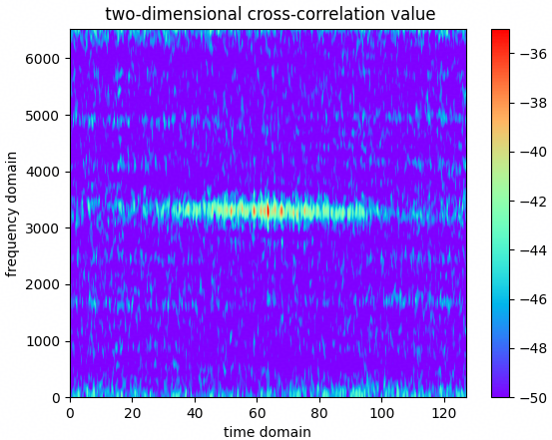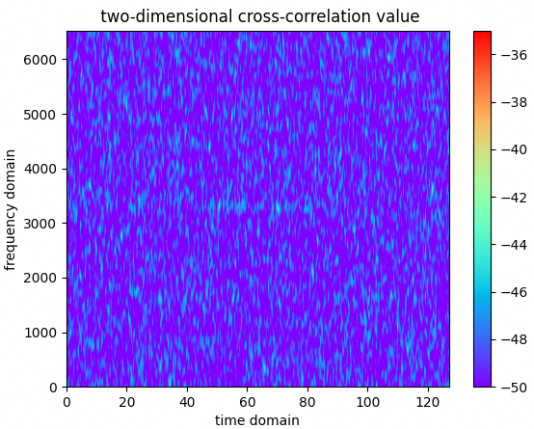
(a) 5G CSI-RS based on Gold sequence (b) sequence enhancement for cross-correlation performance
Figure 11: Cross symbols cross-correlation comparison with different design

Specifically, a long ZC sequence can be mapped to resource elements across multiple symbols, the characteristics of the sequence in both time and frequency domain can be approximated to the those of the CAZAC sequence. The long ZC sequence may be generated according to the following formula:
$x\left(n\right)=x_{q}\left(n mod N_{ZC}\right),0≤n≤{\hat{M}}_{ZC}$,
$x_{q}\left(m\right)=\exp\left(-j\frac{π∙q∙m∙\left(m+1\right)}{N_{ZC}}\right),0≤m≤N_{ZC}-1$.
The length $N_{ZC}$ is given by the largest prime number such that $N_{ZC}<{\hat{M}}_{ZC}$,where ${\hat{M}}_{ZC}=M_{ZC}*N_{symb}$, $M_{ZC}$ is the number of occupied subcarriers, and $N_{symb}$ is the number of occupied OFDM symbols. The mapping method is shown as follows in Figure 12:
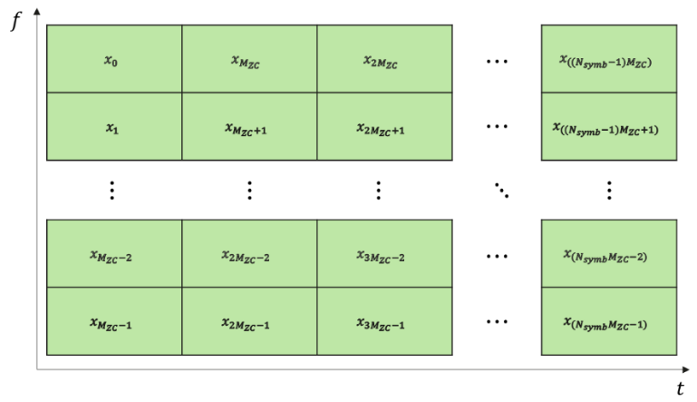
Figure 12: Mapping mode diagram of the long ZC sequence.
The generated long ZC sequence is mapped in an order of first frequency domain and then time domain. The obtained two-dimensional sequence has a performance gain of about 5dB @50% cross-correlation performance point compared to the current NR gold sequence as shown in Figure 13.
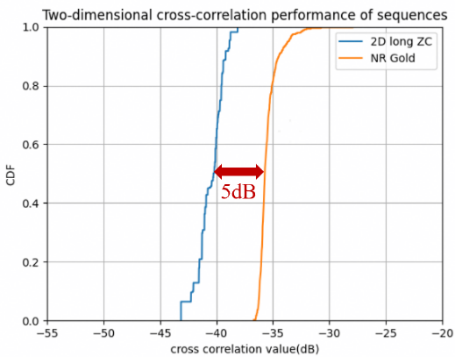
Figure 13: Cross symbols cross-correlation comparison between long ZC sequence and NR Gold.

Overall, based on the above analysis, the study on the enhanced RS for sensing can consider lower PAPR and improved sensing performance for the aNB-UE bistatic sensing in both uplink and downlink. The corresponding impact on communication in terms of performance, resource overhead, and implementation complexity should be studied as well.

Proposal 12: The study on the enhanced RS for sensing for Type1/2 resource can consider the following candidates for aNB-UE/UE-aNB bi-static sensing modes. The corresponding impact on communication in terms of performance and/or resource overhead, and implementation complexity should be studied as well.
- Enhancement on UL RS with low PAPR and improved sensing performance
  - ZC + FDSS
  - OQAM (e.g., Pi/2-BPSK) RS+FDSS
  - Quasi-complementary sequence set (QCSS)
- Enhancement on DL RS with improved sensing performance
  - Gold sequence (CSI-RS) + FDSS
- Improved sensing performance across frequency-time domain and applicable for both DL and UL RS
  - Longer ZC sequence mapping across multiple symbols

Conclusions
In this contribution, we discussed waveform for 6GR ISAC, which leads to the following proposals:

Proposal 1: Ambiguity function is used to characterize waveform for ISAC/sensing,
$AF\left(τ,v\right)=\int_{Φ}{s\left(t\right)s^{*}\left(t-τ\right)e^{i2πvt}}dt$,
where $Φ$ is the integration region of ambiguity function, $τ$ is delay and $v$ is Doppler with continuous value.
Proposal 2: PSLR, ISLR, Tx power gain are used as the performance metrics for ISAC/sensing waveform and signal study.
- PSLR is defined as the ratio of the highest sidelobe peak to the main-lobe peak in a correlation response:
$PSLR=20log⁡(\frac{P_{1}}{P_{0}})$,
where $P_{0}$denotes the largest value of the main lobe of ambiguity function, and $P_{1}$ is the largest value of the side-lobe of ambiguity function.

- ISLR is defined as the ratio of the total sidelobe energy to the main-lobe energy in a correlation response:
$ISLR=10log⁡(\frac{I_{side-lobe}}{I_{main-lobe}})$,
where $I_{main-lobe}$ denotes the power of the main-lobe, and $I_{side-lobe}$ denotes the total power of side-lobe.

- Tx power gain is defined as the PA power back off gain, which is the gain of the maximum transmit power compared with the baseline waveform in compliant with a set of requirements, such as IBE, ACLR and EVM.

Proposal 3: As one further step to move forward, the proponents can justify the relative gain of the enhancement compared to the benchmark using the channel model decided by the proponents for the waveform/sequence study for ISAC.
Proposal 4: 6GR ISAC should study reference signal design for Type1 resource that is sensing performance oriented.
Proposal 5: 6GR ISAC should study reference signal design and waveform for physical channels for Type2 resource that is shared with communication.
Proposal 6: Sensing signals for type1 resource should consider OFDM-based waveform structure.
Proposal 7: NR reference signals (RS), e.g., CSI-RS, and SRS, can be the starting point for sensing RS design and evaluation for Type1 resource that is sensing performance oriented.
Proposal 8: The study of 6G ISAC waveform should focus on CP-OFDM and DFT-s-OFDM-based waveforms and their related enhancements.
Proposal 9: For performance comparison to the benchmark, the new waveform design that can achieve better trade-off between sensing performance and communication performance could be considered.
Proposal 10: Physical channel waveforms candidates for study on Type2 resources shared with communication include
- Pruned QAM for CP-OFDM based
- Floor clipping for DFT-s-OFDM based
Proposal 11: NR reference signals (RS), such as CSI-RS, and SRS, can be the starting point for the RS design and evaluation for Type2 resource that is shared with communication.
Proposal 12: The study on the enhanced RS for sensing for Type1/2 resource can consider the following candidates for aNB-UE/UE-aNB bi-static sensing modes. The corresponding impact on communication in terms of performance and/or resource overhead, and implementation complexity should be studied as well.
- Enhancement on UL RS with low PAPR and improved sensing performance
  - ZC + FDSS
  - OQAM (e.g., Pi/2-BPSK) RS+FDSS
  - Quasi-complementary sequence set (QCSS)
- Enhancement on DL RS with improved sensing performance
  - Gold sequence (CSI-RS) + FDSS
- Improved sensing performance across frequency-time domain and applicable for both DL and UL RS
  - Longer ZC sequence mapping across multiple symbols

References
- RP-260073, RAN TR 38.914, Study on 6G scenarios and requirements (Release 20), V0.4.0 (2026-03).
- RP-251881, New SID: Study on 6G Radio, NTT DOCOMO (Moderator), RAN#108, Prague, Czech Republic, June 9-13, 2025.
- R1-2601944, Sensing integration with communication, Huawei, HiSilicon, RAN1#124bis, St Julian’s, Malta, April 13-17, 2026.
- Richards M A. Fundamentals of radar signal processing[M]. New York: Mcgraw-hill, 2005.
- S. W. Frost and B. Rigling, "Sidelobe predictions for spectrally-disjoint radar waveforms," 2012 IEEE Radar Conference, Atlanta, GA, USA, 2012, pp. 0247-0252, doi: 10.1109/RADAR.2012.6212145.
- 3GPP TS 38.211, “5G; NR; Physical channels and modulation”, V18.4.0, Oct. 2024.

Appendix
This appendix provides how the QCSS is generated.
QCSS can be seen as a generalized version of complete complementary codes, which may offer more flexibility regarding the length of sequences and the size of the set compared to traditional codes. The auto-correlation and cross-correlation functions of QCSS are obtained through coherent accumulation of correlation functions across multiple symbols. They feature low periodic correlation magnitudes and sums. This multi-symbol joint design provides a higher degree of design freedom compared to single-symbol sequence design.
As illustrated in Figure 14, the frequency-domain QCSS is denoted by $X∈C^{M×K}$, where $M$denotes the number of subcarriers and $K$ denotes the number of symbol channels. By performing independent $N$-point IFFT operation on each column of the QCSS matrix, the time-domain sensing signal $Z∈C^{N×K}$ can be directly obtained for subsequent transmission.
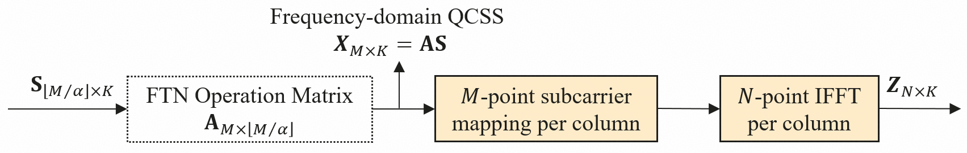
Figure 14: QCSS-based sensing signals transmission.
Let $U$ be a QCSS group consisting of $D$QCSS, denoted by $U=\{X_{1}, X_{2},…, X_{D}\}$ where each QCSS sequence set consists of $K$ sequences with length$M$. For clarity, each QCSS sequence set is expressed as $X_{d}=\left[x_{d}^{1}, x_{d}^{2},…,x_{d}^{K}\right], ∀d∈\{1,2, …, D\}$. For $∀d∈\left\{1,2, …, D\right\}$, the periodic auto-AF (AAF) function is
$$AAF\left(X_{d}, τ,f_{d}\right)=\sum_{k=0}^{K-1}{AF\left(x_{d}^{k}, τ,f_{d}\right)e^{j2πf_{d}kT_{c}}},$$
where $τ$ is the delay index, $f_{d}$ is the Doppler shift, and $T_{c}$ denotes the slow-time interval. For $∀m,n∈\left\{1,2, …, D\right\}, m≠n,$the periodic cross-AF (CAF) function of QCSS $X_{m}$ and $X_{n}$ in $U$ is
$$CAF\left(X_{m},X_{n},τ,f_{d}\right)=\sum_{k=0}^{K-1}{AF\left(x_{m}^{k}, x_{n}^{k},τ,f_{d}\right)e^{j2πf_{d}kT_{c}}}.$$
To evaluate the AF proprieties of QCSS, the auto-AF peak-to-sidelobe ratio (APSLR) and cross-AF peak-to-sidelobe ratio (CPSLR) are defined. Specifically, the APSLR for one QCSS is defined as the ratio between the peak value of the auto-ambiguity function and its maximum sidelobe level, calculated over the coherent accumulation of ambiguity functions across $K$ OFDM symbols. The APSLR of the whole QCSS group $U$ is finally defined as the maximum APSLR of all $M$ QCSSs. Similarly, The CPSLR is defined as the maximum value of the global cross-correlation between any two distinct QCSSs within the group $U$. To evaluate the sensing coverage capability of QCSS, the PAPR is defined as the maximum PAPR of all $MK$ OFDM symbols.
Note that $APSLR$, $CPSLR$ and PAPR are determined by the optimization of QCSS group $U$, which further impact the sensing accuracy, interference level, and coverage capability, respectively. The QCSS group $U$ is obtained by minimizing the following objective function
$\min_{U}ωAPSLR+(1-ω)CPSLR$ $+ σ max⁡(PAPR-p_{th},0)$,
where $0≤ω≤1$ denotes the weight parameter, the last term represents the $l_{1}$ penalty function, $σ>0$ is the penalty factor, and $p_{th}$ denotes the PAPR requirement of sensing signals. It is difficult to construct the QCSSs with satisfying the above sensing performance requirement. Therefore, the minimum objective function value can be obtained by computer generation search methods.
Moreover, searching can be implemented in multiple domains, including frequency domain search, Faster-than-Nyquist (FTN) domain and so on. Among diverse search domains, FTN signaling presents prominent superiority in QCSS sequence generation. With discrete Fourier transform (DFT) and truncation processing, FTN signals can obtain a relatively low PAPR, which enables faster convergence in computer search and achieves superior overall performance. To achieve this, the FTN-based QCSS can be obtained by adding a FTN operation matrix, as illustrate in Figure 14.
The input FTN signal matrix is denoted by $S∈C^{\left\lfloor M/α\right\rfloor ×K}$, where $0<α≤1$ denotes the FTN factor. The matrix $A∈C^{M×\left\lfloor M/α\right\rfloor }$ denotes the $\left\lfloor M/α\right\rfloor$ columns of a $M×M$ DFT matrix, which is referred as FTN operation matrix. Through the FTN operation, one may attain the frequency-domain QCSS, i.e., $X=AS$, followed by an N-point IFFT applied independently to each column, resulting in the time-domain output signal $Z$. Note that QCSS can be defined in FTN domain or frequency domain, i.e., $S$ or $X$.
As a basic example, the QCSS is generated based on FTN signaling. Simulation results of PAPR, auto-AF and cross-AF curves for QCSS are presented in Figure 8. The related simulation parameters include $D= 30, K = 4, M = 273, α = 0.5$, $N = 2048$, $f_{d} = 0 Hz$, $ω$ = 0.5, $σ$ = 1, and $p_{th}$ = 2 dB. Performance evaluation shows that the proposed QCSS sequences achieve superior PAPR and ambiguity function characteristics compared to existing ZC sequences.

